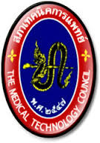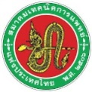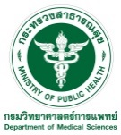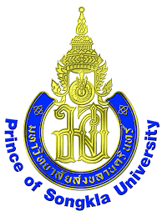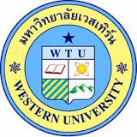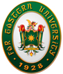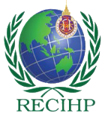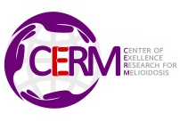
International Conference on Biomedical Sciences and Medical Technology 2019 (ICBMS & MT 2019)
“Research and Innovation for Health”
June 20-21, 2019 Grand Fortune Hotel, Nakhon Si Thammarat, Thailand
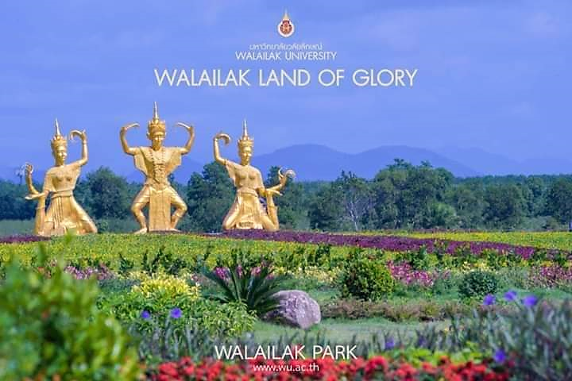
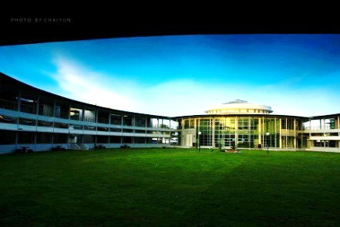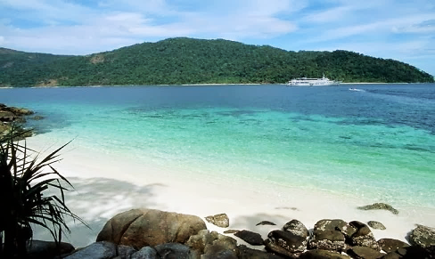

Time | June 20th 2019
08:00-09:00 Hr | Registration
09:00-10:30 Hr | Opening Ceremony and Welcome Speech
10:30-10:50 Hr | Refreshment & Poster Session
10:50-12:00 Hr | “Molecular genetics of Alzheimer's' diseases”  Keynote Speaker: Prof. Dr. Steven Estus, University of Kentucky, USA  Chairman: Asst. Prof. Dr. Voravuth Somsak, Co-chairman: Lecturer Saruda Kuraeiad
12:00-13:00 Hr | Lunch & Poster session
 | Section A: Biomedical Sciences  “Non-Infectious Diseases and Innovation”  Chairman: Assoc. Prof. Dr. Nutjaree Jeenduang  Co-chairman: Assist. Prof. Dr. Warangkana Chunglok | Section B: Medical Technology  “Current Medical Laboratory Technology”  Chairman: Asst. Prof. Dr. Manit Nuinoon  Co-chairman: Dr. Duangjai Phiewkum
13:00-13:45 Hr  13:45-14:20 Hr  14:15-14:30 Hr  14:30-14:45 Hr  14.45-15.00 Hr | “Health Care & High Quality of Life Towards the CVD Patients”  Invited Speaker: Assoc. Prof. Dr. Manikandan Panchatcharam  LSU Health Sciences Center, USA  Molecular genetic of Dyslipidemia  Invited Speaker: Assoc. Prof. Dr. Nutjaree Jeenduang  Biomedical Sciences, Walailak University  Oral Presenter#1  Oral Presenter#2  Oral Presenter#3 | “Precision Medicine and Its Related to Medical Technology 4.0”  Invited Speaker: Dr. Salakchit Chutiphongwiwet, MT  President, Association of Medical Technology of Thailand  “Current Advancement in Medical Laboratory Technology in Japan”  Invited Speaker: Assoc. Prof. Dr. Yoshiko Kudo  The International University of Health and Welfare, Japan  Oral Presenter#1  Oral Presenter#2  Oral Presenter#3
15:00-15:20 Hr | Refreshment & Poster Session
15:20-16:00 Hr  16:00-16:15 Hr  16:15-16:30 Hr  16:30-16:45 Hr  16.45-17.00 Hr  17.00-18.00 Hr | “Metal Toxic Mechanisms and Detox Strategies”  Chairman: Dr. Supabhorn Yimthiang/ Saruda Kuraeiad  Invited Speaker: Prof. Dr. Soisungwan Satarug  University of Queensland, Australia  Oral Presenter#1  Oral Presenter#2  Oral Presenter#3  Oral Presenter#4  Member and Research Group Meeting | Molecular Genetic  “Thai Genome”  Invited Speaker: Dr.Warangkhana On-Suang, MT  Medical Sciences Department, Ministry of Public Health  Oral Presenter#1  Oral Presenter#2  Oral Presenter#3  Oral Presenter#4  Association of Medical Technology of Thailand Member Meeting
18:00-22:00 Hr | Welcome Reception/MT-WU Alumni Homecoming Party

Time | June 21st 2019
08:00-09:00 Hr | Registration
09:00-10:15 Hr | “Current Advancement Medical Laboratory Technology Practices Toward Thailand Innovation 4.0”  Keynote Speaker: Dr. Opas Kankawinpong, Director, Department of Medical Sciences, Public Health Ministry  Chairman: Assoc. Prof. Dr. Sahapat Barusrux, Co-chairman: Asst. Prof. Dr. Theerakamol Pengsakul
10:15-10:45 Hr | Refreshment & Poster Session
10:45-12:00 Hr | “Melioidosis”  Keynote Speaker: Asst. Prof. Dr. Apichai Tuanyok, University of Florida, USA  Chairman: Asst. Prof. Dr. Wiyada Kwanhian, Co-chairman: Asst. Prof. Dr. Sueptrakool Wisessombat
12:00-13:00 Hr | Lunch & Poster Session
 | Section A: Biomedical Sciences  “Melioidosis: Clinical Investigation and Treatment”  Chairman: Asst. Prof. Dr. Wiyada Kwanhian,  Co-chairman: Asst. Prof. Dr. Sueptrakool Wisessombat | Section B: Medical Technology  Quality Assurance for Best Practices Laboratory  Chairman: Asst. Prof. Dr. Penchom Janwan  Co-chairman: Lecturer Kornyok Kamdee
13:00-14:00 Hr  14:00-15:20 Hr  14:20-14:40 Hr  14:40-15:00 Hr | “Melioidosis: Clinical Investigation and Treatment”  Invited Speaker: Assoc. Prof. Dr. Sarunyu Chusri  Prince of Songkla University  Oral Presenter#1  Oral Presenter#2  Oral Presenter#3 | “MOPH: The Best Practice of Laboratory Quality Standard”  Invited Speaker: Dr. Patravee Soisangwan  Director, Laboratory Quality Standards, Department of Medical Sciences, Ministry of Public health  Oral Presenter#1  Oral Presenter#2  Oral Presenter#3
15:00-15:20 Hr | Refreshment & Poster session
15:20-16:00 Hr | “Advance and Research in Medical Parasitology”  Invited Speaker: Asst. Prof. Dr. Theerakamol Pengsakul  Faculty of Medical Technology, Prince of Songkla University | “Quality Assurance for Best Practices Laboratory”  Invited Speaker: Mrs Ranee TaDe-in  Laboratory Director, Yala Hospital  Chairman: Asst. Prof. Dr. Apsorn Sattayakhom  Co-chairman: Lecturer Pongphan Pongpanitanont
16:00-16:30 Hr | Closing Remarks and Awards
Remarks : Session A will be presented in English version / Session B will be presented in Thai version
Importance Date:
Abstract / Proceeding / Full Manuscript Submission Deadline 31 MAR 2019
Abstract / Proceeding Accept or Reject Notification 22 APRIL 2019
Abstract / Proceeding Revision Deadline 25 APRIL 2019
Final Abstract / Proceeding Acceptance Notification 28 APRIL 2019
Full Manuscript Accept or Reject Notification 3 MAY 2019
Full Manuscript Revision Deadline 10 MAY 2019
Final Full Manuscript Acceptance Notification 20 MAY 2019
Full manuscripts will be considered by reviewers for publication in Walailak Journal of Science and Technology (WJST), SJR (SCOPUS) (Q3) (Special issue)

Registration Fees and Payments (International Participants)
PROGRAM A | PARTICIPANTS (A1)  Regular Fees  (Before 15 FEB 2019) | PARTICIPANTS (A2)  Late Fees  (After 31 MAR 2019)
Thai Participants | 3,000 THB | 3,500 THB
International Participants | 150 USD | 200 USD
Thai Students | 2,000 THB | 2,500 THB
International Students | 100 USD | 150 USD
Participants Without Presentation | 3,000 THB (150 USD)
PROGRAM B +Tour 2 Days and 1 Night at Sichon Cabana Resort (22-23 JUNE 2019)
Thai Participants | 5,500 THB | 6,000 THB
International Participants | 250 USD | 300 USD
Thai Students | 4,500 THB | 5,000 THB
International Students | 200 USD | 250 USD
Participants Without Presentation | 5,500 THB (250 USD)

Pay by Bank Transfer
Bank Name Krungthai Bank
Account Name International Conference BMS-MT (2029)
Account Number 828-3-01965-1
Swift Code KRTHTHBK

Attention: These registration fees are not included the bank transfer charge and other charge
Contact Person Assoc. Prof. Dr. Manas Kotepui
E-mail: icbms.mt2019@gmail.com
Tel: +66 (0) 7567 2137 or +66 (0) 95439 2469

Information, Registration, and Submission at http://icbms-mt2019.wu.ac.th

Organizing Committee

Dr. Sukhum Kanchanapimai, Public Health Ministry Permanent Secretary, Public Health Ministry
Professor Dr. Steven Estus, University of Kentucky, USA Consultant
Professor Dr. Soisungwan Satarug, Queenland University, Australia Consultant
Assistant Professor Dr. Apichai Tuanyok, University of Florida, USA Consultant
Dr. Salakchit Chutiphongwiwet, President AMTT Consultant
Associate Professor Dr. Jitbanjong Tangpong, Walailak University Consultant
Assistant Professor Boonpayao Loawhajinda, Western University Consultant

Assistant Professor Dr. Voravuth Somsak, Walailak University Chair
Associate Professor Dr. Saranyu Chusri, Prince of Songkla University Committee
Associate Professor Dr. Sahapat Barusrux, Walailak University Committee
Associate Professor Dr. Monthon Lertcanawanichakul Walailak University Committee
Associate Professor Dr. Nutjaree Jeenduang, Walailak University Committee
Assistant Professor Dr. Warangkana Chunglok, Walailak University Committee
Dr. Udom Chanasit, UP Marketing General, Ltd. Committee
Mr Nivet Theinprasit, Gibe Thai, Ltd Committee
Dr. Warangkhana On-Suang, MT, Department of Medical Sciences, Public Health Ministry Committee
Mrs Ranee Thade-in, Yala Hospital, Yala, Thailand Committee
Ms Jurairat Ratthanalertnavee, TaKuapha Hospital, Phangnga Committee
Assistant Professor Dr. Wiyada Kwanhian, Walailak University Committee
Assistant Professor Dr. Sueptrakool Wisessombat, Walailak University Committee
Assistant Professor Dr. Apsorn Sattayakhom, Walailak University Committee
Assistant Professor Dr. Phuangthip Bhoopong, Walailak University Committee
Assistant Professor Dr. Nurdina Charong, Walailak University Committee
Assistant t Professor Dr. Theerakamol Pengsakul, Prince of Songkla University Committee
Assoc. Prof. Dr. Yoshiko Kudo, International University of Health and Welfare, Japan Committee
Dr. Jiraporn Jaroenpool, Walailak University Committee
Associate Professor Dr. Manus Kotepui Committee

